39.18: a)
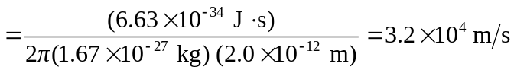
b) For minimum uncertainty,
